Purpose: To provide step by step instructions on how to adjust the camera to correct for a rainbow bead resolution issue.

Reference Materials Related to this Work Instruction:
- Procedure WOLF-N1 01 Installation QC or Procedure WOLF-N1 02 Demo QC
- Procedure WOLF Troubleshooting Rainbow Bead Resolution Issues

Additional Tools Required:
- ESD Strap
- Examination gloves
- Hex Keys
  - 2.5 mm
  - 2 mm
  - 1.5 mm
- Torque wrench

Background Information:
If a WOLF presents with rainbow bead resolution issues, that does NOT imply that there is a misalignment in the instrument optics. In fact, the optical system of the WOLF is one of the MOST STABLE components and is most likely NOT the root cause of the poor rainbow bead resolution. Although the instrument optics may not be the root cause for poor rainbow bead resolution, adjusting its components (camera, laser rotation mirror) can correct the issue. Adjusting the camera does not physically alter the location of the laser beam, but rather it alters the location where the auto-align designated chip center is with respect to the laser beam. Therefore, if moving the chip center in the X-axis can improve the resolution of rainbow beads to achieve acceptable CV criteria (Gen2 CV% Criteria), then adjusting the camera should correct for the rainbow bead resolution issue.

Prior to performing this procedure, the “Procedure WOLF-N1 01 Installation QC” and “Procedure WOLF Troubleshooting Rainbow Bead Resolution Issues” should have already been completed, and thus the following have already been observed/tested:
- When visually assessing the laser beam using the reference cartridge, there MAY be a major laser beam shift compared to the WOLF laser alignment report. However, a major laser beam shift does NOT NEED to be present to perform this procedure.
- Analysis of rainbow beads at the auto-align designated chip center did not yield acceptable CV values (Gen2 CV% Criteria) when at least TWO different sorting cartridges were tested.
- The cartridge fixture has been tested for insertion stability and was determined to be stable.
- The servos motors have been tested for movement stability and were determined to be stable.
- Moving the chip center more than 5um in either direction yielded acceptable CVs of rainbow beads. Moreover, the distance and direction of movement needed to obtain acceptable CVs was consistent for both of the sorting cartridges tested. Note: there needs to be consistency between cartridges NOT absolute precision.
- If moving the chip center less than 5um along the X-axis resulted in acceptable CVs, then NO adjustment is needed to fix rainbow bead resolution issues. Resolution issue was most likely cartridge-related.
- If moving the cartridge ANY distance or direction along the X-axis did NOT yield acceptable CVs, then this procedure should NOT be completed. Proceed to adjust the laser reflection mirror to correct for the rainbow bead resolution issue according to “Procedure WOLF_06 Polaris Laser Reflection Mirror Adjustment.”
Additional Assumptions:
- Sorting cartridge #2 is still inserted into the WOLF. The distance and direction necessary to achieve acceptable CV criteria is already known for this cartridge.
- This procedure MUST be completed with a sorting cartridge, so if a new sorting cartridge needs to be inserted, please follow sections “10. WOLF Sorting cartridge Quality Control: priming, alignment, and calibration” and “11. WOLF Sorting Cartridge quality control: optical alignment test – rainbow beads” found within “Procedure WOLF-N1 01 Installation QC” to set-up the cartridge. Then perform section “5.2 Test rainbow bead resolution by moving the chip center in X-plane” found within “Procedure WOLF Troubleshooting Rainbow Bead Resolution Issues” to determine the distance and direction necessary to obtain acceptable CV values.

Camera Adjustment Procedure:

  - Remove the WOLF top cover following “Procedure WOLF_02 Cover and Back Panel Removal”.
  - Make sure the J9 cable is well connected to the camera to prevent a disconnect during adjustment (Figure 1).
  - Open the “Chip Alignment” window and activate the focusing graphic interface (crosshairs) by positioning the cursor on the live image of chip center while simultaneously pressing the mouse center button (Figure 2A).
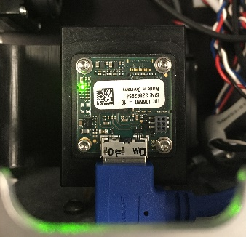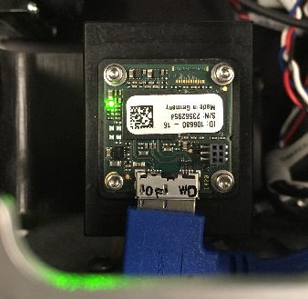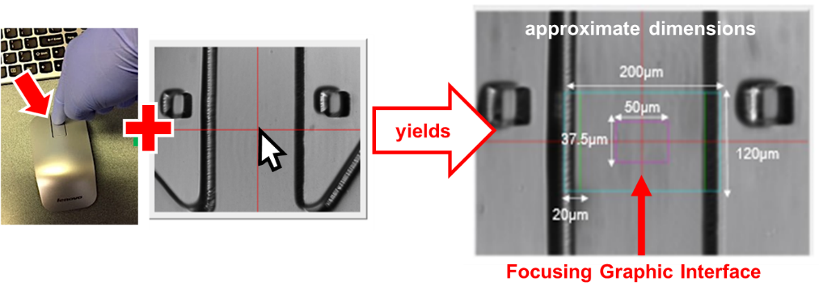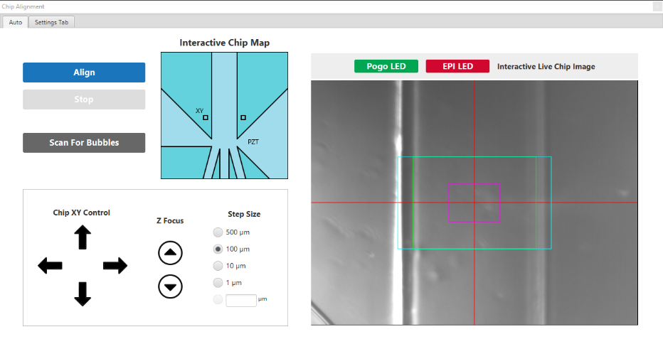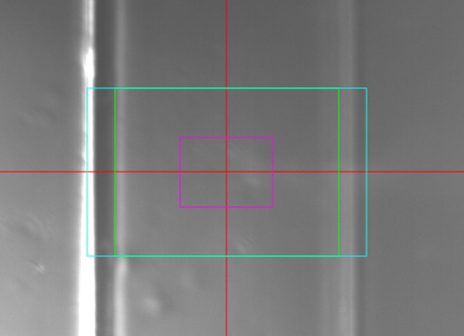
Figure 1. Proper connection of J9 cable to the camera.
Ensure that the J9 cable is securely attached to the camera. If the connection appears to become detached at either end (right image), please fix the connection prior to continuing.
Camera
J9 Cable
Figure 2. Activation of focusing graphic interface.
Figure 2A. Activate the focusing box by pressing the center button of the mouse (red arrow) when the cursor is positioned on the chip center.

Figure 2B. When using CoC cartridges to adjust the camera, utilize the features of the focusing graphic interface as reference markers.

ZOOM
Focusing Graphic Interface “Crosshairs”
Utilize channel walls as reference markers
  - Re-align the sorting cartridge by pressing the XY marker in the “Interactive Chip Map” then the “Align” button in the “Auto” tab of the Chip Alignment window.
  - Take a screenshot of the chip center in the “Auto” tab, and take a screenshot of the chip center values within the “Advanced Settings” tab, you may need to press ctrl+shift+m while in the Chip Alignment Window to access the “Advanced Settings” tab.
  - Keep the screenshot of the chip center open to use as a reference visual for what the auto-aligned chip center position looks like. Utilize the focusing graphic interface as reference markers (Figure 2B; Figure 7-top row).
  - Move the chip center to the previously determined optimal X-position using the arrows in the “Auto” tab in the Chip Alignment pop-up window (Figure 3; Figure 7-middle row).
Utilize the “Manual” tab to move the live chip image to the left/right along the X-axis.
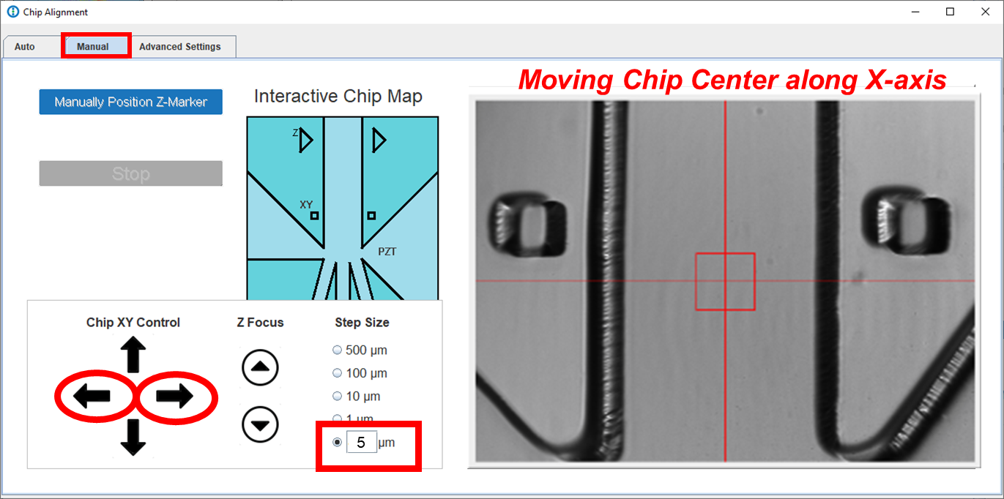
Figure 3. Chip center can be shifted using tools found within the “Manual” tab
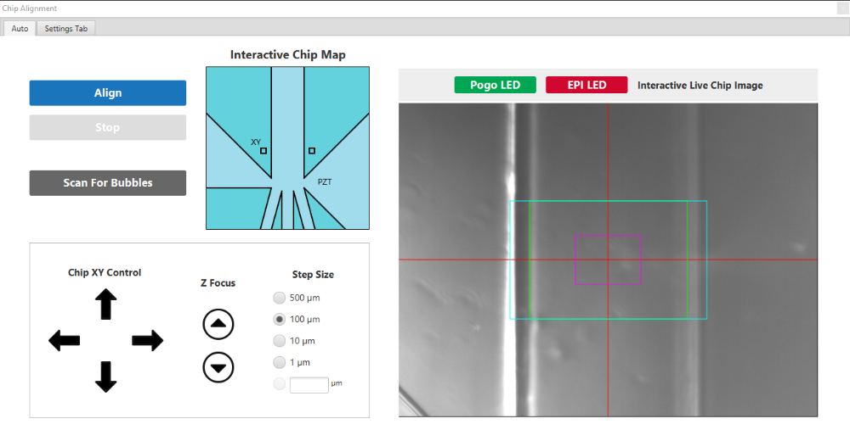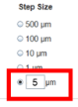
Figure 3. Chip center can be shifted using tools found within the “Auto” tab
Utilize the “Auto” tab to move the live chip image to the left/right along the X-axis.

  - Press down on the top of the camera using your thumb (Figure 4B).
  - Without removing one’s finger, carefully loosen the 4 camera screws, using a 1.5mm hex driver/key (approximately 1/4 turn) (Figure 4A).
Note: once the 4 camera screws are loosened, it’s critical to keep finger pressed onto camera to maintain control. Do NOT remove one’s finger until the screws are securely re-tightened at the end of the adjustment process.
Also, while the camera screws are loosened, monitor the indicator light found on the camera. This light indicates the camera connection status. When the camera is properly connected, the light should be illuminated green (Figure 4B). If the indicator light starts blinking that implies the camera has become disconnected from the WOLF. To re-connect the camera, go to the “advanced settings” tab in the Chip Alignment pop-up window and press “reset camera” button (Figure 5).
  - Gently slide the camera using your index finger. (Figure 4B).
Note: To determine the appropriate direction to move the camera, please refer to Figure 4C. The goal of the camera movement is to match the real-time live image with the screenshot of the auto-aligned chip center (which was taken before moving the cartridge to the optimal X-position) (Figure 7)
  - Observe the live camera image as it moves, using the screenshot of the chip center image as a reference (Figure 7). While adjusting the camera along the X-axis, monitor the location of the PZT chamber or any unique cartridge blemishes to ensure there is no shift in Y (Figure 6).
Note: While adjusting the camera, keep your thumb pressing down on the camera chip to hold it steady. While adjusting the camera, be careful NOT to change the Y position of the chip center, and do NOT induce any tilt (Figure 6). Movement in the Y direction could lead to extended calibration times and potential calibration errors. Small changes in the camera Y-position (up to 20um) can be compensated by software, changes greater than 20um will negatively affect calibration. Furthermore, cartridge tilt could yield issues with automatic cartridge alignment, which in turn could induce further optical resolution issues.
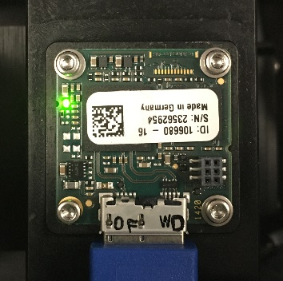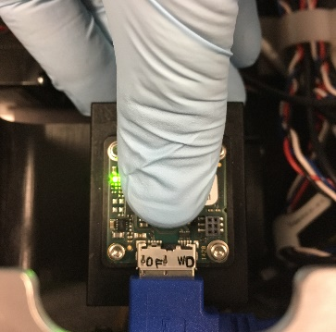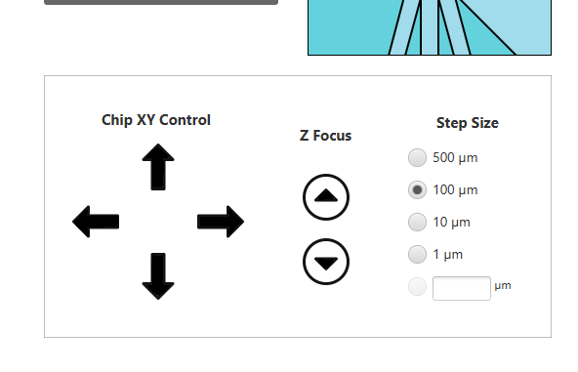
Figure 4. Process of adjusting the camera.
Figure 4A. Loosen the four screws securing the camera, highlighted by red circles. When camera is successfully connected, the indicator on the camera should illuminate green (white arrow).
Figure 4B. Control/move the camera by applying a constant, downward pressure onto the top of the camera with your thumb.
Figure 4C. Camera movement direction in reference to live camera image. Because it is difficult to make fine adjustments in a single axis, it is typically simpler to begin moving the camera chip and learn its flips and inversions by trial and error than to reference this image.
Front of machine

Left
Right
Up
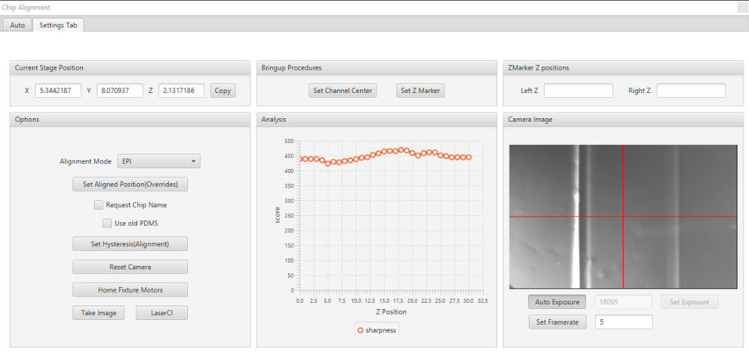
Figure 5. If camera becomes disconnected, reset live image using Advanced Settings Tab
If the camera becomes disconnected during the adjustment process, select the “reset camera” button found within the “Advanced Settings” tab.
If camera disconnects during movement, press “reset camera”
Current Stage Position / Cartridge Location
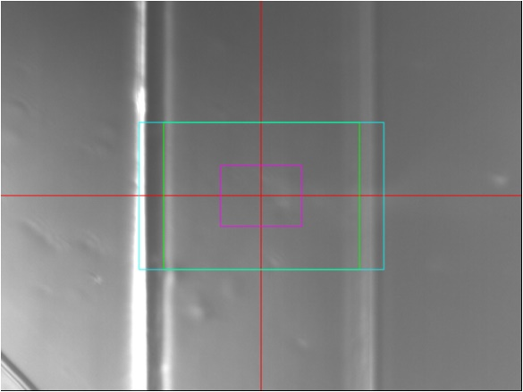
Figure 6. Utilize markings within cartridge to ensure the camera has not shifted in Y-direction.

Figure 6B. When using CoC cartridges to adjust the camera, monitor the location of the PZT chamber or any unique cartridge blemishes to ensure there is no shift in Y

PZT Chamber
Unique Blemishes
  - Continue to move the camera until the camera live image matches the reference screenshot of the chip center taken before adjusting the camera (Figure 7-bottom row).
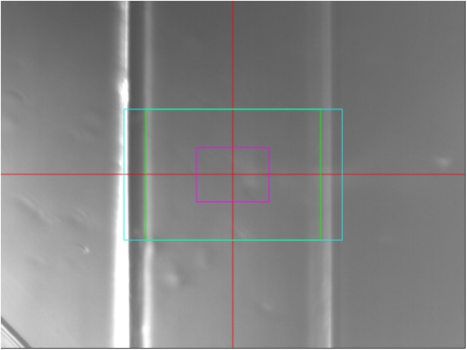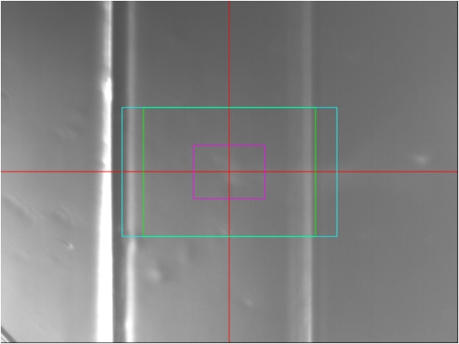
Figure 7. Summary figure of live camera screen throughout the adjustment process.
When adjusting the camera, the first step is to align the cartridge and take a screenshot of Auto-Align chip center (top row). After alignment, move the chip center image to the previously determined distance (middle row). In this example, the chip center was moved 15um to the right (middle row). During the camera adjustment, physically move the camera until the live chip image (bottom row) matches the screenshot of the Auto-Align chip center (top row). Utilize the crosshair as reference markers during adjustment (red arrows).
Figure 7B. Images for COC Cartridges
Auto-Align Chip Center
Move Cartridge 15um Right (to optimal performance)
Camera Moved To Match Auto-Align Chip Center
  - Once the live image matches the reference image, re-tighten camera screws using the torque specs below:
Component reference | Screw thread | Hex bit size | Torque specification
WOLF camera | M2x6mm SHCS | 1.5 mm | 2 in-lb

  - Re-align the cartridge by pressing the XY marker in the “Interactive Chip Map” then the “Align” button on the “Auto” tab of the chip alignment pop-up window.
  - Once alignment is complete, take a screenshot of the chip center in the “Auto” tab, and take a screenshot of the chip center values within the “Advanced Settings” tab (Figure 5). Name the file “Auto aligned - after camera adj”.
  - Analyze rainbow beads again to assess optical resolution. Press “same sample” button to trigger the start of sample acquisition.
Note: When analyzing rainbow beads always (1) analyze a similar number of events to compare with the previous file; (2) press “Same Sample” button to start acquisition;
  - Assess the CV values for all the fluorescent channels using the horizontal gates surrounding the brightest peak in each histogram.
  - If the CV values meet criteria, then the rainbow bead resolution issue has been corrected for. Proceed to run size beads according to “Section 12. WOLF wet cartridge quality control: optical alignment test – Size beads” found within the “Procedure WOLF-N1 01 Installation QC”.
  - If the CV values do not meet criteria, proceed back to the “Procedure WOLF Troubleshooting Rainbow Bead Resolution Issues” to determine the next steps to correct for the rainbow bead resolution issues.

Revision History:
 | ISSUED DATE | Description of Change | Author
A | 12/09/2019 | Document created | A.Bartakova
B | 12/15/2019 | New version – changed wording based on Beth Leary’s suggestions | A.Bartakova
C | 04/24/2020 | New version – added angle measurement workflow to avoid camera tilt. Added guidelines for movement in the Y axis. Reviewed by Manna Doud on 04/26/2020. | A. Bartakova
D | 06/15/2020 | New version edited for clarity. Figure representing a COC universal cartridge added. | A. Bartakova
E | 09/28/2020 | Reviewed; see comments/track changes | B. Desai
F | 10/21/2020 | New version edited for clarity. Figures added. | E. Rubio de la Torre
G | 02/11/2021 | V2.1 Edited/Reduced for increased compatibility with the Procedure for Troubleshooting Rainbow Bead Resolution Issues | E. Leary
H | 10/22/2021 | V3.1 First draft of WOLF G2 version | J. Holland

