Purpose: To provide step by step instructions on how to remove and replace the XYZ stage within the WOLF G2.

Definitions & Acronyms: N/A

Tools Guide:
- Examination gloves
- 2.5 mm Hex Bit
- In-Lb Torque Driver

Preparing the WOLF G2:
- This procedure begins with a unit that has the top cover and cartridge fixture removed. Refer to the disassembly portion of the WOLF G2 Cartridge Fixture Replacement Procedure for instructions to get to this stage.

Disconnection of Motor and Encoder Cables
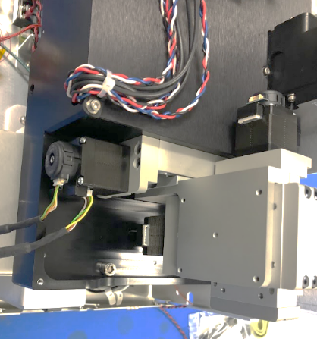
Z-Axis
Y-Axis
X-Axis
Carefully disconnect all 3 motor cables and all 3 encoder cables. See NOTE above for removing cable mount.
NOTE: Remove M3 SHCS from this location to detach Z-Axis cables from the stage.
Encoder
Motor

Removal of Fixture Mounting Plate
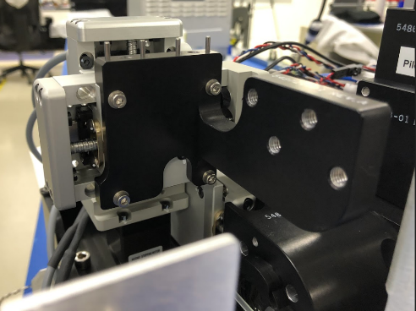
Remove the 4 indicated screws with their corresponding Belleville washers,
Take care not to drop the washers during removal.
Set aside the fixture mounting plate for re-assembly.

Old XYZ Stage Removal
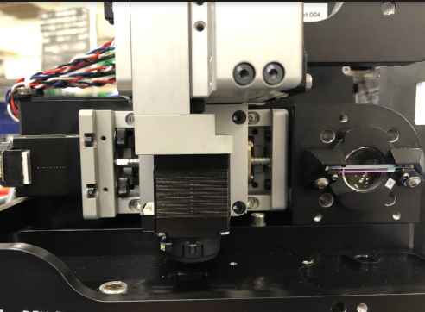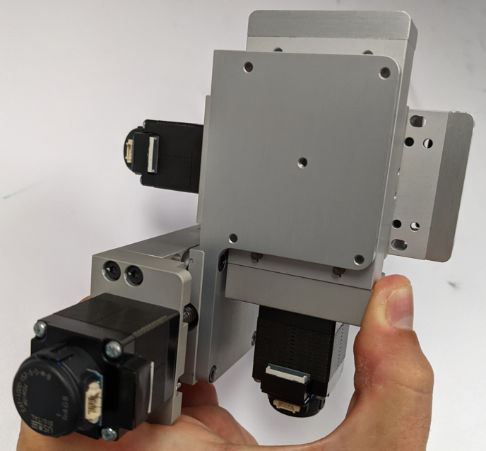
Manually slide the X axis of the stage so that all 4 of the mounting screws are exposed.
While holding the stage with one hand to support its weight, loosen the 4 mounting M3 screws.
Remove the stage assembly.

Stage Assembly

New XYZ Stage Installation
Mount using the 4 screws + serrated washers from the old XYZ stage, inserted in the oval holes on the bracket, hold against the right and bottom datum “Blue Arrow” and tighten in a “crisscross” pattern as shown when tightening, “Green Arrows”.
Torque 10 in-lb.
Re-Assembly of Fixture Mounting Plate
Hold in the direction of the blue arrow to datum the bracket while tightening.
4X SHCS + Belleville washer - torque 10 in-lb.

Reconnection of Motor and Encoder Cables
Z-Axis
Y-Axis
X-Axis
Plug in the provided cables, match the label on the cable with the axis shown above.
Reattach the cable mount using the existing M3 SHCS and Belleville washer - torque 5 in-lb.
NOTE: Re-attach Z-Axis cables to the stage.

Functional Verification
Correct function should be verified by performing the WOLF G2 Installation QC procedure.

Revision History:
 | ISSUED DATE | Description of Change | Author
A | 07/5/2022 | Original draft | M. Benchimol

